Mount Kilauea, HI

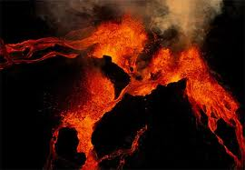

This is one of the largest active craters in the world. It is also the youngest volcano in Hawaii. It is the southeastern most volcano on the Big Island. The magma comes from more than 60 km deep in the ocean floor of the Earth. The summit of Kilauea has a rounded curve. It also has constant lava out-pouring from it and has been consistently erupting since 1983. It is regarded as the most dangerous volcano in the U.S. It is capable of non-explosive eruptions, but has also had large explosive reactions that have devastated the land around it.
Since 2008, more sulfur dioxide continues to be released from the mountain. This is creating an increased level of volcanic smog, which is leading to potential air quality hazards.

Paricutin, Mexico

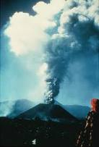

The Paricutin volcano is considered one of the Seven Natural Wonders of the World. It is part of the Michoacan-Guanajuato Volcanic Field, which covers a lot of west central Mexico. It has a steep-sided slope. The eruption, in 1943, was made of ash and stones – loose pyroclastic material. The volcanic eruption lasted over a period of 8 years (which is a rare long period for this type of volcano, most last only a few months and rarely more than a few years).
The volcano has been quiet since its eruption in 1943. The magma has since solidified and the volcano will never erupt again. This volcano is very unique in that no one died directly from the lava or asphyxiation.

Mount Pinatubo, Philippines

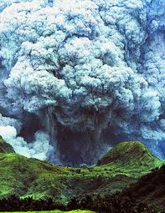

Mount Pinatubo is a mountain that is located in the chain of volcanoes known as the Ring of Fire that borders the Pacific Ocean. The 1991 eruption came some 450 – 500 years after the last known eruptive activity. This is the largest eruption that has occurred that anyone can remember and the second largest land eruption in the 20th century. Mount Pinatubo is a large, nearly symmetrical structure that is composed of layers of lava and pyroclastic deposits.
Mount Pinatubo had a large pyroclastic flow that includes hot gases, glowing ash and large rock fragments. Many people were evacuated from the mountainside so many lives were saved as the magma erupted and lava poured down the mountainside. However, surrounding areas and the world felt the effects of the eruption. Damage came from the pyroclastic flows and ash deposits. It ejected about 10 billion metric tons of magma (that’s a lot of magma!) and 20 million tons of sulfur dioxide. This brought vast quantities of minerals and metals to the surface of the environment. Over the following months, the aerosols formed a global layer of sulfuric acid haze and the ozone depletion temporarily increased dramatically.

Crater Lake, Oregon

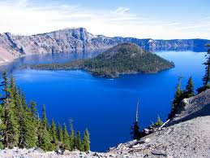

This is the main feature of Crater Lake National Park and is famous for its deep blue color and water clarity. Crater Lake has a large depression that is filled with water. It has a unique full sized tree in the middle of the lake, which has been well preserved due to the cold temperatures of the lake. Crater Lake formed when Mount Mazama violently erupted and collapsed. You can think of it as it grew, blew, fell and filled. This means that Mount Mazama grew and then it blew violently spreading ash. Then the mountain fell and filled with water.
It has been dormant for about 5,000 to 6,000 years but could have another eruption at any time. Right now it is a tourist site that you can come and visit!

Kimberlite Pipes, South Africa

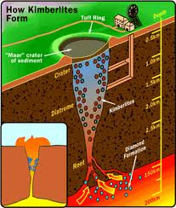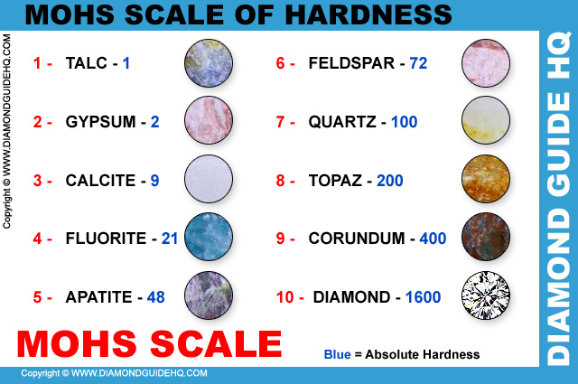

This volcano is fed magma through pipes that connects the magma chamber to the surface. The Kimberlite Pipes are the most important source of mined diamonds today. The kimberlites form deep within the mantle. The rock fills the pipes deep within the Earth, at least 150 kilometers, where pressure is high enough for diamonds to form. This process is very rare and that is why diamonds are so expensive and rare.
The formation of the kimberlite happens deep within the Earth and the mantle compositions are erupted rapidly and violently. The eruption carries diamonds to Earth’s surface. This has the potential to provide information on what makes up the deep mantle and melting processes that occur.

Columbia Plateau

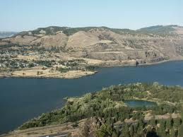

The Columbia Plateau is located across Washington, Oregon and Idaho. It is in between the Cascade Range and the Rocky Mountains. A long time ago, the fissure of the Columbia Plateau spread out about 63,000 square miles over the Pacific Northwest. This formed a large igneous province. The lava flowed and there was a large amount that spread over more than 6,000 feet. As the molten rock came to the surface through the fissure, the Earth’s crust slowly sank into the space left by the rising lava. The lava that poured on the crust created a large plateau (area of land) that is now called the Columbia Basin.
In the Columbia Plateau where lava once spread, fossil leaf impressions, petrified wood, fossil insects and bones of vertebrate animals were found. Interesting…

