Name:
STUDY GUIDE: Plate Tectonics, Earthquakes, and Volcanoes

Brain POP - Plate Tectonics
1. _______________ was the name of the supercontinent that existed millions of years ago.
2. The surface, or ____________, of the Earth is broken into about ____ plates that float on the liquid _______________.
3. When the plates move, the ________________________ shift along with them. We don’t notice the ground moving because they only move a few _______________ each year.
4. Volcanoes, _____________________, _______________________, and trenches occur at active _____________________ between the plates.
5. Divergent boundaries are where plates are moving ________________ and new ________________ is created by liquid rock pushing up from the mantle.
6. Convergent boundaries are where plates are moving ________________ each other. Sometimes one plate ______________, or is subducted under another.
7. Transform boundaries are where plates __________________ horizontally past one each other and cause ________________.
8. The plates are always ___________________ slowly changing the face of the ___________.

1. Explain the theory plate tectonics
_______________________________________________________________________________________________________________________________________________________________________________________________________________________________________

2. All of the following support the theory of continental drift except _____.
A. The continents seemed to fit together like pieces of a puzzle.
B. There are similar fossils on different continents.
C. Mountain ranges on different continents lined up.
D. The North Pole and Antarctica are covered in ice.

3.What hypothesis states that the continents were once joined to form a single supercontinent?
a. | plate tectonics | c. | continental drift
b. | seafloor spreading | d. | paleomagnetism

4. Use the word bank below to complete the sentences.
seismograph Sea floor spreading earthquakes melt P Waves
Epicenter Continental-continental Metamorphic S Waves

Which of the following occur at divergent boundaries? ________________________
An earthquakes _____________________ is occurs directly above the focus.
Mountains form at ________________________________ convergent boundaries.
________________ rocks form due to heat a pressure.
Magma forms when rocks from the upper crust and mantle ______________________.
A _________________________ is the instrument that records earthquake waves.
_____________ shake particles at a right angle to the direction of travel. ________________ change a materials volume by expansion and compression.

Predictions are made on the assumption that __________________ are repetitive (they occur on the same fault lines).

5. Match structures formed at each plate boundary
A B C
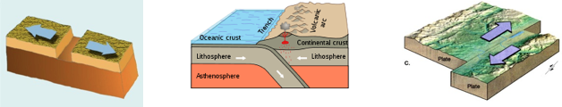
____ 1. Convergent ____ 2. Divergent ____ 3. Transform

Explain what happens (plate motion) and what features occur at each plate boundary.
Convergent ( Hint: Three types)
______________________________________________________________________________________________________________________________________________________________________________________________________________________________________________________________________________________________________________________________________________________________________________________________________________________________________________________________________________
Divergent (Hint: Two types)
______________________________________________________________________________________________________________________________________________________________________________________________________________________________________________________________________________________________________________________________________________________________________________________________________________________________________________________________________________

Transform
_______________________________________________________________________________________________________________________________________________________________________________________________________________________________________
6. In the chart below compare and contrast magma and lava.
Magma | Lava

Circle the best answer
1. Most of the active volcanoes on Earth are located in a belt known as the ____.
a. | Ring of Lava | c. | East African Rift Valley
b. | Ring of Fire | d. | circum-Atlantic belt

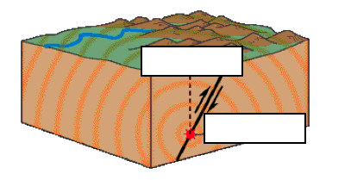
- Label the epicenter and focal point.

- At which type of plate boundary do earthquakes typically occur?

- Complete the chart below.
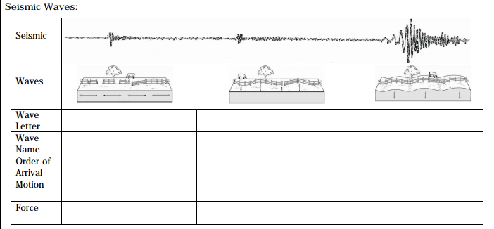
1. What are the causes of damage during or after an earthquake (5 in total)?  1) _________________________________  2) _________________________________  3) _________________________________  4) _________________________________  5) _________________________________ | 2. How can we predict earthquakes?  ________________________________________________________________________________________________________________________________________________________
___3. Which of the following affects the amount of destruction caused by earthquake vibrations?  a. The design of structures  b. The nature of the material on which structures are built  c. The intensity and duration of the vibrations  d. All of the above | 4. What is the minimal number of seismic stations that is needed to determine the location of an Earthquake’s epicenter?  a. One  b. Two  c. Three  d. Four
Explain the hazards to humans from an earthquake ---> | ___________________________________ ___________________________________ ___________________________________

D. Volcanoes:
___1. The particles ejected in volcanic eruptions are called _____.  a. Calderas  b. Volcanic stocks  c. Laccoliths  d. Pyroclastic material | 2. List the types of volcanoes and explain each of them.
3. Most of the active volcanoes on Earth are located in a belt known as the ____.  a. Ring of Fire  b. Ring of Lava  c. East African Rift Valley  d. Mid-Pacific Rise | Which of the following factors helps determine whether a volcanic eruption will be violent or relatively quiet?  a. amount of dissolved gases in the magma  b. temperature of the magma  c. composition of the magma  d. all of the above

Explain precautions that can be made to protect life from various geohazards . Some examples include landslides, earthquakes, tsunamis, sinkholes, groundwater pollution, and flooding.
________________________________________________________________________ ________________________________________________________________________________________________________________________________________________ ________________________________________________________________________

