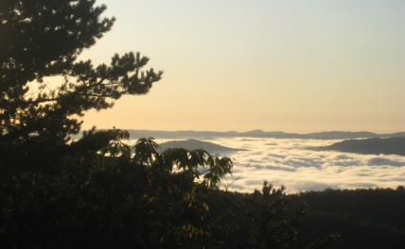

North Carolina’s Geologic History

Page ES 14 (after chapter 11 in the middle of the book)

- What did the process of mountain building that raised the Appalachians involve?

- Where was the shoreline of NC between 500 and 600 million years ago?

- How were the Blue Ridge Mountains created?

- What formed the base of the piedmont?

- In picture B, what is creating heat to form the volcanic islands?

- What completed the formation of the Appalachians? How long ago was it?

- What process involving the seafloor caused North America and Africa to split? What body of water was created?

- Sketch the plate activity- label the plates, landforms and boundary types. Include the dates.

North Carolina’s Geologic History

Page ES 14 (after chapter 11 in the middle of the book)

- What did the process of mountain building that raised the Appalachians involve?

- Where was the shoreline of NC between 500 and 600 million years ago?

- How were the Blue Ridge Mountains created?

- What formed the base of the piedmont?

- In picture B, what is creating heat to form the volcanic islands?

- What completed the formation of the Appalachians? How long ago was it?

- What process involving the seafloor caused North America and Africa to split? What body of water was created?

- Sketch the plate activity- label the plates, landforms and boundary types. Include the dates.

