**Unit 1: Scientific Method & What is Biology?**

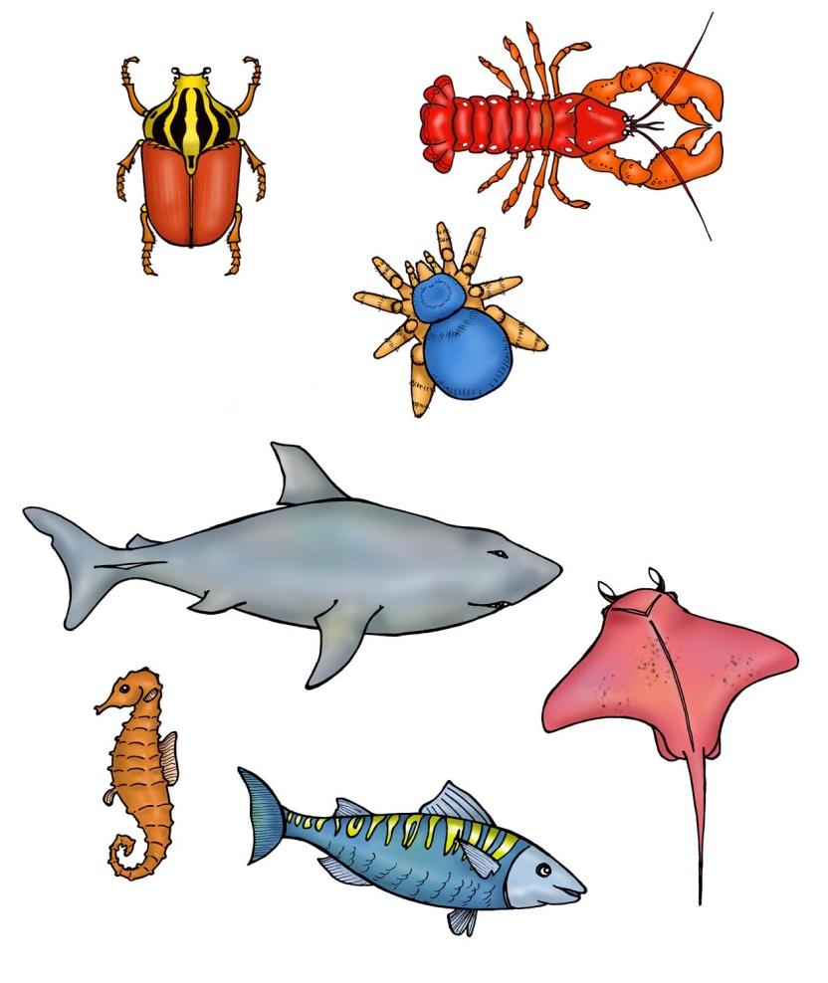

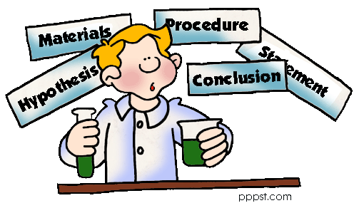

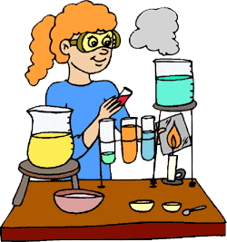

**Unit Vocabulary:**

Choose *at least* 5 words to add to your glossary. Words with an asterisk (\*) are **required**.

* Hypothesis
* Observation
* Inference
* \*Theory
* Control group
* Experimental group
* Dependent variable
* Independent variable
* \*Biotic factor
* \*Abiotic factor

**Unit 1 Test:**

**U1-2**

**Scientific Method Notes**

|  |  |  |
| --- | --- | --- |
| **STEP** | **KEY THINGS TO REMEMBER** | **EXAMPLES** |
|  | **MUST BE \_\_\_\_\_\_\_\_\_\_\_\_\_\_\_\_\_ & \_\_\_\_\_\_\_\_\_\_\_\_\_\_\_\_.**  Be specific.  (Best what???) | a. Which fertilizer will lead to the most plant growth?  b. Which gum is the best?  c. Why doesn’t my crush like me? |
|  | **GATHER \_\_\_\_\_\_\_\_\_\_\_\_\_\_\_\_\_\_\_**     1. **\_\_\_\_\_\_\_\_\_\_\_\_\_\_\_\_\_\_\_\_\_:**   (FACTS ONLY)   1. **\_\_\_\_\_\_\_\_\_\_\_\_\_\_\_\_\_\_\_\_\_:** (assumptions/judgments) | Observation:  Inference: |
|  | **\_\_\_\_\_\_\_\_\_\_ AN OUTCOME**  **If** (\_\_\_\_\_\_\_)**,** **then** (\_\_\_\_\_\_\_).  MUST:   * BE TESTABLE * MEASUREABLE * Make sense based on observations | 1. **If** I put on cologne or perfume, **then** \_\_\_\_\_\_\_\_\_\_\_\_\_\_\_\_\_\_\_\_\_\_\_\_\_\_\_\_\_\_\_\_\_\_\_\_\_\_\_\_\_\_. 2. **If** he \_\_\_\_\_\_\_\_\_\_\_\_\_\_\_\_\_\_, **then** he will lose body fat. |
|  | **COLLECT \_\_\_\_\_\_\_\_**  (perform the experiment) | Quantitative data:  (Quantity)  Qualitative data:  (Quality)#&$"while they recite the ord he word "10 minutes.y! |
|  | **ANALYZE & \_\_\_\_\_\_\_\_\_\_\_\_**   * Summarize data * Return to your hypothesis | Hypothesis ≠ Conclusion:  Hypothesis = Conclusion: |

**A hypothesis that “survives” several different experiments with the same result becomes a \_\_\_\_\_\_\_\_\_\_\_.**

Ex. All organisms evolved from a common ancestor = *Theory* of Evolution

**Let’s do it ourselves!**

|  |  |
| --- | --- |
| **STEP** | **PAPER TOWEL LAB** |
|  | Which brand of paper towels is the most absorbent? |
|  |  |
|  |  |
|  | #&$"while they recite the ord he word "10 minutes.y! |
|  | **U1-1** |

C:\tempie\Temporary Internet Files\Content.IE5\POJIWUKV\MC900311286[1].wmf

**Paper Towel Lab**

**U1-7**

***Experiment:***

# Materials:

50 ml graduated cylinder 3 brands of paper towels

100 ml beaker tap water

scissors ruler

***Method:***

1. Obtain three different brands of paper towels from Ms. Phillips.
2. Label one **Brand A,** one **Brand B,** and one **Brand C.**
3. Cut a 4-inch square out of one sheet from each roll of paper towels.
4. Measure 25 ml of water into a graduated cylinder.
5. Pour the water into the 100 ml beaker.
6. Fold one paper towel square so that it will soak up as much water as possible and put it in the beaker.
7. After soaking the paper towel, hold it horizontally over the beaker for 10 seconds. This lets the excess water drain back into the beaker.
8. Pour the water remaining in the beaker back into the graduated cylinder and calculate how much has been absorbed. (HINT: subtract the amount in the cylinder from 25 ml.) Record your results in the chart below.)
9. Repeat steps **4** through **8** with the same brand of paper towels (Trial 2). Make sure you fold the paper towel the same way both times.
10. Repeat steps **4** through **9** with the other paper towel brands. Make sure that you fold them both in the same way as you did the original brand.
11. Record the price of each roll of paper towels and the number of square feet per roll.

***Data:***

|  |  |  |  |  |  |
| --- | --- | --- | --- | --- | --- |
| **Brand** | **Price per roll** | **Square feet per roll** | **Water absorbed trial 1** | **Water absorbed trial 2** | **Average water absorbed** |
| **A** |  |  |  |  |  |
| **B** |  |  |  |  |  |
| **C** |  |  |  |  |  |

|  |  |  |  |  |  |  |  |  |  |  |  |  |  |  |  |  |
| --- | --- | --- | --- | --- | --- | --- | --- | --- | --- | --- | --- | --- | --- | --- | --- | --- |
|  |  |  |  |  |  |  |  |  |  |  |  |  |  |  |  |  |
|  |  |  |  |  |  |  |  |  |  |  |  |  |  |  |  |  |
|  |  |  |  |  |  |  |  |  |  |  |  |  |  |  |  |  |
|  |  |  |  |  |  |  |  |  |  |  |  |  |  |  |  |  |
|  |  |  |  |  |  |  |  |  |  |  |  |  |  |  |  |  |
|  |  |  |  |  |  |  |  |  |  |  |  |  |  |  |  |  |
|  |  |  |  |  |  |  |  |  |  |  |  |  |  |  |  |  |
|  |  |  |  |  |  |  |  |  |  |  |  |  |  |  |  |  |
|  |  |  |  |  |  |  |  |  |  |  |  |  |  |  |  |  |
|  |  |  |  |  |  |  |  |  |  |  |  |  |  |  |  |  |
|  |  |  |  |  |  |  |  |  |  |  |  |  |  |  |  |  |
|  |  |  |  |  |  |  |  |  |  |  |  |  |  |  |  |  |

mL of water absorbed

Use a bar graph to show the **average amount of water** absorbed by each paper towel brand. Be sure to label the y-axis with numbers that represent the amount of liquid.

## Brand Brand Brand

**A B C**

***Conclusions:***

**U1-8**

1. Which brand absorbed the most water?
2. Making sure that the sheets of paper towel were all the same size is an example of *controlling* an experiment. Why do we make sure that every sheet of paper towel is the same size?
3. What other factors might have influenced or affected your experiment? Did you think of these when you first started?
4. Calculate the cost per square foot of each brand of paper towels (divide the price of the roll by the square feet of a roll):

Brand A:

Brand B:

Brand C:

1. Which brand is the most economical (lowest cost per square feet) to buy? \_\_\_\_\_\_\_\_\_\_\_\_\_\_\_\_

Is it the same brand that was the most absorbent? \_\_\_\_\_\_\_\_\_\_\_\_\_\_\_\_\_\_\_\_

1. Which product do you conclude is the best buy, considering both absorbency and cost?

Lab Report Template

Use this template to create your lab report for your Paper Towel lab on piece of notebook paper.

**Title**: \* a brief, concise, yet descriptive title

**Statement of the Problem**: \* What question(s) are you trying to answer?

\* Include any preliminary observations or background information about the subject

**Hypothesis**: \* Write a possible solution for the problem.

\* Make sure this possible solution is a complete sentence.

\* Make sure the statement is testable.

**Materials**:

\* Make a list of ALL items used in the lab.

**Procedure**:

\* Write a paragraph (complete sentences) which explains what you did in the lab.

\* Your procedure should be written so that anyone else could repeat the experiment.

**Results (Data):**

\* This section should include any data tables, observations, or additional notes you make during the lab.

\* You may attach a separate sheet(s) if necessary.

\* All tables, graphs and charts should be labeled appropriately

**Conclusions**:

\* Accept or reject your hypothesis.

\* EXPLAIN why you accepted or rejected your hypothesis using data from the lab.

\* Include a summary of the data - average, highest, lowest..etc to help the reader understand your results

\* List one thing you learned and describe how it applies to a real-life situation.

\*Discuss possible errors that could have occurred in the collection of the data (experimental errors)

**Independent and Dependent Variables**

**U1-2**

|  |  |
| --- | --- |
| CAUSE  **INDEPENDENT VARIABLE** | EFFECT  **DEPENDENT VARIABLE** |
| C:\tempie\Temporary Internet Files\Content.IE5\3V3F1HJR\MC900441468[1].png**The variable that is being \_\_\_\_\_\_\_\_\_\_\_\_\_\_\_\_\_\_\_\_by the scientist or naturally.**  ex. How many hours a student studies  **Examples:**  1) How does sleep affect a student’s test grade?  IV: \_\_\_\_\_\_\_\_\_\_\_\_\_\_\_\_\_\_\_\_\_\_\_\_\_\_\_\_\_\_    2) How does a fatty diet affect a person’s weight?  IV: \_\_\_\_\_\_\_\_\_\_\_\_\_\_\_\_\_\_\_\_\_\_\_\_\_\_\_\_\_\_  3) How does time affect the length of a person’s hair?  IV: \_\_\_\_\_\_\_\_\_\_\_\_\_\_\_\_\_\_\_\_\_\_\_\_\_\_\_\_\_\_ | **The variable that is being \_\_\_\_\_\_\_\_\_\_\_\_\_\_\_\_\_\_\_\_\_\_.**  C:\tempie\Temporary Internet Files\Content.IE5\00XUMV1D\MC900281970[1].wmfex. A student’s test grade  **Examples:**  1) Can Neutrogena face wash decrease acne breakouts?  DV: \_\_\_\_\_\_\_\_\_\_\_\_\_\_\_\_\_\_\_\_\_\_\_\_\_\_\_\_\_  2) Does height affect how far a person can jump?  DV: \_\_\_\_\_\_\_\_\_\_\_\_\_\_\_\_\_\_\_\_\_\_\_\_\_\_\_\_\_  3) How does temperature affect plant growth?  DV: \_\_\_\_\_\_\_\_\_\_\_\_\_\_\_\_\_\_\_\_\_\_\_\_\_\_\_\_\_ |
| **GRAPHING IV & DV:**  **\_\_\_\_\_\_\_\_\_\_\_\_ is (almost) always an independent variable** | |

**PRACTICE!**

**Identify the independent and dependent variable in the examples below:**

1. How does hydration (drinking enough fluids) affect an athlete’s performance?

IV: \_\_\_\_\_\_\_\_\_\_\_\_\_\_\_\_\_\_\_\_\_\_\_\_\_\_\_\_\_\_\_ DV: \_\_\_\_\_\_\_\_\_\_\_\_\_\_\_\_\_\_\_\_\_\_\_\_\_\_\_\_\_\_\_\_\_\_

1. Does playing an instrument improve academic performance?

IV: \_\_\_\_\_\_\_\_\_\_\_\_\_\_\_\_\_\_\_\_\_\_\_\_\_\_\_\_\_\_\_ DV: \_\_\_\_\_\_\_\_\_\_\_\_\_\_\_\_\_\_\_\_\_\_\_\_\_\_\_\_\_\_\_\_\_

1. Does sex education in schools decrease the spread of sexually transmitted diseases?

IV: \_\_\_\_\_\_\_\_\_\_\_\_\_\_\_\_\_\_\_\_\_\_\_\_\_\_\_\_\_\_\_ DV: \_\_\_\_\_\_\_\_\_\_\_\_\_\_\_\_\_\_\_\_\_\_\_\_\_\_\_\_\_\_\_\_\_\_

1. Is there a relationship between socio-economic status and obesity?

IV: \_\_\_\_\_\_\_\_\_\_\_\_\_\_\_\_\_\_\_\_\_\_\_\_\_\_\_\_\_\_\_\_ DV: \_\_\_\_\_\_\_\_\_\_\_\_\_\_\_\_\_\_\_\_\_\_\_\_\_\_\_\_\_\_\_\_\_\_

**Graphing**

**U1-3**

|  |  |
| --- | --- |
| **LINE GRAPH**  Function: \_\_\_\_\_\_\_\_\_\_\_\_\_\_\_\_\_\_\_\_\_\_\_\_\_\_\_\_\_\_\_\_\_  http://www.awe.asn.au/branches/sunshine-coast/images/commom_line_graph.jpg | **BAR GRAPH**  Function: \_\_\_\_\_\_\_\_\_\_\_\_\_\_\_\_\_\_\_\_\_\_\_\_\_\_\_\_\_\_\_\_\_\_\_\_\_\_\_\_\_\_  http://image.tutorvista.com/Qimages/QD/5130.gif |
| **PIE GRAPH**  Function: \_\_\_\_\_\_\_\_\_\_\_\_\_\_\_\_\_\_\_\_\_\_\_\_\_\_\_\_\_\_\_\_\_\_  **Pie Graph of Day's Activities** | **SCATTER PLOT**  Function: \_\_\_\_\_\_\_\_\_\_\_\_\_\_\_\_\_\_\_\_\_\_\_\_\_\_\_\_\_\_\_\_\_\_\_\_\_\_\_\_  age_scatterplot |

*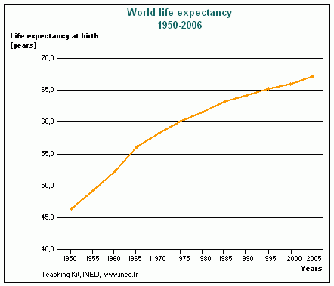*

**PRACTICE!**

**Use the graph to the right to answer the following questions.**

1. What is the title of the graph?

2. What is the dependent variable? (What is being measured?)

3. What is the independent variable? (What is the scientist changing/what categories is the scientist looking at?)

4. What is happening to the line over time? (Is it increasing? Decreasing? Staying constant?)

**U1-4**

5. What was the life expectancy in 1975?

6. What was the life expectancy in 1980?

7. What was the life expectancy in 1967?

8. When was the life expectancy higher, in 1950 or in 1975?

9. When was the life expectancy higher, in 2000 or in 1990?

10. When was the life expectancy higher, in 1957 or in 1978? Explain how you know using a complete sentence with data from the table.

**Control & Experimental Groups**

C:\tempie\Temporary Internet Files\Content.IE5\RWTDHS22\MC900088948[1].wmf

**Control group:**

**Experimental group:**

**Examples:**

|  |  |
| --- | --- |
| Type of Birth control | % of couples that got pregnant  Control Group: \_\_\_\_\_\_\_\_\_\_\_\_\_\_\_\_\_\_\_\_\_ |
| None | 85 |
| Spermicide | 29 |
| Diaphragm | 16 |
| Condom | 15 |

1. 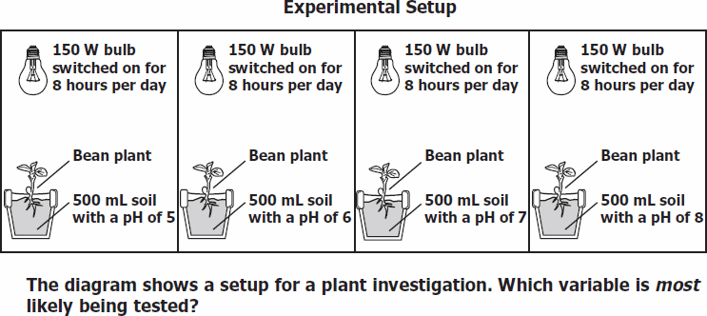

List the 5 different variables in this experiment: What is the experimental group?:

1. \_\_\_\_\_\_\_\_\_\_\_\_\_\_\_\_\_\_\_\_\_\_\_\_\_\_\_\_\_\_\_\_\_\_

2.

3.

4.

5.

**PRACTICE!**

**U1-5**

**Uh oh…the people that did the following experiments forgot to include a control group—they can’t accurately draw conclusions about their experiments! You need to help them be better scientists! Explain what the control group would be for each:**

***Example***: Does drinking Gatorade help you make more layups in basketball? 10 people drink one cup of Gatorade. What should the other group of 10 people do?

|  |  |
| --- | --- |
| **Experimental Group** | **Control Group** |
| http://upload.wikimedia.org/wikipedia/en/thumb/3/3e/GatoradeGlogoconverted.svg/200px-GatoradeGlogoconverted.svg.png  **How many?:** 10 people  **What?:** Drink Gatorade | http://www.clker.com/cliparts/6/d/9/8/1287244981509738217water-droplet-icon.jpg  **How many?:** 10 people  **What?:** Drink water |

1. **Does drinking milk with Vitamin D added make you stronger?**

100 people drink 2 cups of milk with Vitamin D per day for a year and the scientist measures how much weight they can lift. What should the control group be?

|  |  |
| --- | --- |
| **Experimental Group** | **Control Group** |
| **How many?**  *100* people  2 cups  **What?** Milk with Vitamin D | **How many?** \_\_\_ people  \_\_\_ cups  **What?** |

1. **Does singing to plants help them grow taller?**

A person sings to 5 plants for 10 minutes a day. What should the control group be?

|  |  |
| --- | --- |
| **Experimental Group** | **Control Group** |
| **How many?** \_\_\_ plants  \_\_\_ minutes  **What?** Singing | **How many?** \_\_\_ plants  \_\_\_ minutes  **What?** |

1. **Does fertilizer help plants grow taller?**

A scientist adds 5 drops of Fertilizer A to one pot, 5 drops of Fertilizer B to a second pot, and 5 drops of Fertilizer C to a third pot. What should be put in the fourth pot?

|  |  |
| --- | --- |
| **Experimental Group** | **Control Group** |
| **How many?** 5 drops  **What?** Fertilizer | **How many?**  **What?** |

1. **Does putting a banana inside a paper bag make it ripen faster?**

A banana is left inside a paper bag for 10 days. What should the control group be?

|  |  |
| --- | --- |
| **Experimental Group** | **Control Group** |
| **How many?** 1 banana,  10 days  **What?** In a paper bag | **How many?**  **What?** |

1. **Are LGBT youth more at risk for depression?**

**U1-6**

A research psychologist surveyed 1000 LGBT (lesbian, gay, bisexual, transsexual) youth in Chicago and determined what percent of them are depressed. To find out if the number is higher than for straight youth, what should the control group be?

|  |  |
| --- | --- |
| **Experimental Group** | **Control Group** |
| **How many?** \_\_\_ youth  **What?** LGBT youth  *Real statistic: 83% LGBT youth are depressed, which is 5 times as many as straight youth* | **How many?** \_\_\_ youth  **What?** |

1. **Does having a transgendered principal affect students’ grades?**

A researcher measures the GPAs of 100 students the year after their principal had gender reassignment surgery. To find out of the GPAs of these students changed after their principal’s surgery, what should the control group be?

|  |  |
| --- | --- |
| **Experimental Group** | **Control Group** |
| **How many?** \_\_\_ students  **What?** GPA of students after principal’s sex change | **How many?** \_\_\_ students  **What?** |

1. **Are LGBT students more likely to drop out of school due to bullying about their sexual orientation?**

A scientist measures the percentage of LGBT students at 200 schools across the country that drop out of school because they have been bullied about their sexual orientation. What should the control group be?

|  |  |
| --- | --- |
| **Experimental Group** | **Control Group** |
| **How many?** \_\_\_ schools  **What?** LGBT students  *Real statistic: 28% LGBT students drop out due to bullying* | **How many?** \_\_\_ schools  **What?** |

**What is Biology?**

**U1-9**

Biology is the study of \_\_\_\_\_\_\_\_\_\_\_!

**Why am I taking this class?**

Biology can enhance your \_\_\_\_\_\_\_\_\_\_\_\_\_\_\_\_\_\_\_\_ of your \_\_\_\_\_\_\_\_\_\_ and the living Earth.

Working \_\_\_\_\_\_\_\_\_\_\_\_\_\_ in this course and passing the \_\_\_\_\_\_\_\_\_\_\_ puts you on the path to graduating from high school and going to college!

**Abiotic/Biotic Inquiry Lab:**

**Objective**: In this activity students will distinguish between abiotic and biotic factors in an ecosystem. They will demonstrate this by identifying and classifying various biotic and abiotic objects.

**Biotic = \_\_\_\_\_\_\_\_\_\_\_\_\_\_\_\_\_**parts of an ecosystem

**Abiotic = \_\_\_\_\_\_\_\_\_\_\_\_\_\_\_\_**parts of an ecosystem

**Directions for the Lab:**

1. At each station you will make 2 observations.

**Use your senses!**

1. You must identify if it should be classified as biotic or abiotic.
2. Then Ms. Simmons will reveal the objects and you will answer analysis questions.

|  |  |  |  |
| --- | --- | --- | --- |
| **Item #** | **Observation 1** | **Observation 2** | **Biotic (B) or Abiotic (A)** |
| **1** |  |  |  |
| **2** |  |  |  |
| **3** |  |  |  |
| **4** |  |  |  |
| **5** |  |  |  |
| **6** |  |  |  |
| **7** |  |  |  |
| **8** |  |  |  |
| **9** |  |  |  |
| **10** |  |  |  |

**U1-10**

|  |
| --- |
| * Whale * Mushroom * Water * Desert * Paper * Glass * Temperature * Coral * Clouds * Snail * Mold * Grass * Hair * Flowers * Ocean * Tree * Rocks * Dirt * Plastic * Grapes * Oxygen |

1. Enter the items from the following list into the Venn diagram below. In the center place items that contain both abiotic and biotic factors.

**Biotic**

**Abiotic**

*All biotic and abiotic factors are interrelated. In nature you will find that if one factor is changed or removed, it impacts the availability of other resources within the ecosystem. Knowing this, give an example of what might happen given the following situations.*

In the open space place either an (**A**) for **abiotic** or a (**B**) for **biotic** to identify the **bolded** object. Then answer the question on the lines provided.

1. All of the **rocks** (\_\_\_) are removed from a desert ecosystem, what would happen to the population of rock dwelling **lizards** (\_\_\_) and the animals that eat the lizards?   
   \_\_\_\_\_\_\_\_\_\_\_\_\_\_\_\_\_\_\_\_\_\_\_\_\_\_\_\_\_\_\_\_\_\_\_\_\_\_\_\_\_\_\_\_\_\_\_\_\_\_\_\_\_\_\_\_\_\_\_\_\_\_\_\_\_\_\_\_\_\_\_\_\_\_\_\_\_\_\_\_\_\_\_\_\_\_\_\_\_\_\_\_\_\_\_\_\_\_\_\_\_\_\_\_\_\_\_\_\_\_\_\_\_\_\_\_\_\_\_\_\_\_\_\_\_\_\_\_\_\_\_\_\_\_\_\_\_\_\_\_\_\_\_\_\_\_\_\_
2. A ten mile area of **trees** (\_\_\_) is removed from the tropical rainforest. How will this affect the amount of **water** (\_\_\_) and the amount of **oxygen** (\_\_\_) in the area?   
   \_\_\_\_\_\_\_\_\_\_\_\_\_\_\_\_\_\_\_\_\_\_\_\_\_\_\_\_\_\_\_\_\_\_\_\_\_\_\_\_\_\_\_\_\_\_\_\_\_\_\_\_\_\_\_\_\_\_\_\_\_\_\_\_\_\_\_\_\_\_\_\_\_\_\_\_\_\_\_\_\_\_\_\_\_\_\_\_\_\_\_\_\_\_\_\_\_\_\_\_\_\_\_\_\_\_\_\_\_\_\_\_\_\_\_\_\_\_\_\_\_\_\_\_\_\_\_\_\_\_\_\_\_\_\_\_\_\_\_\_\_\_\_\_\_\_\_\_

**Analysis Questions:**

1. What is biology?
2. What is the difference between a **biotic** and **abiotic** factor?
3. List **3 biotic** factors that you encounter every day.

Explain why one of these is **biotic**.

1. List **3 abiotic** factors that you encounter every day.

Explain why one of these is **abiotic**.

8 Characteristics of Life

**U1-11**

|  |  |  |
| --- | --- | --- |
|  | **Definition** | **Examples** |
| **S\_\_\_\_\_** |  | Protein synthesis, |
| **T\_\_\_\_\_** |  |  |
| **E\_\_\_\_\_** |  |  |
| **R\_\_\_\_\_** |  |  |
| **N\_\_\_\_\_** |  |  |
| **G\_\_\_\_\_** |  |  |
| **R\_\_\_\_\_** |  |  |
| **R\_\_\_\_\_** |  |  |

**Unit 1 Review**

**U1-13**

**“\_\_\_\_ DEPENDS ON \_\_\_\_\_”**

This helps us remember that:

\_\_\_\_\_\_\_\_\_\_\_\_\_\_ variable

\_\_\_\_\_\_\_\_\_\_\_\_\_\_ variable

**The INDEPENDENT variable is the CAUSE.**

**The DEPENDENT variable is the EFFECT.**

&

A hypothesis is written in a cause-effect format!

(this makes it easy to identify the 2 variables)

**IF (cause), THEN (effect).**

If I chew gum (cause), then I will lose weight (effect)

**Practice**:

**Identify the IV and DV in the following hypotheses.**

1. If Ms. Phillips drinks milk every morning, then she will grow tall and strong.   
   IV:  
   DV:
2. If Michael studies for his test, then he will get a high grade.  
   IV:  
   DV:
3. If birds eat rice, then they will explode.  
   IV:  
   DV:

**U1-14**

1. Elijah conducted an experiment that tested the hypothesis that eating donuts will make a person fat. Elijah decided that he need to make a **bar graph** to show his data because \_\_\_\_\_\_\_\_\_\_\_\_\_\_\_\_\_\_\_\_\_\_\_\_\_\_\_\_\_\_\_\_\_\_\_\_\_\_\_\_\_\_\_\_\_\_\_\_\_\_\_\_.
2. IV:  
   DV:
3. Label the axes on Isaiah’s graph below with the two variables.

\_\_\_\_\_\_\_\_\_\_\_\_\_\_

\_\_\_\_\_\_\_\_\_\_\_\_\_\_\_

1. Compare and contrast Control groups and Experimental groups:

**EOC Questions**

1. When drawing a graph that measures average family income over a period of 50 years, the independent variable  (x axis) is:
2. Income
3. Average
4. Years
5. None of the above

|  |
| --- |
| 1. The graph below shows the relative average mass of the ovaries of a certain species of toad each month for a period of 1 year. Which inference could correctly be made from this graph? 2. imageEggs are produced within the ovaries between May and October. 3. Eggs are released into the environment during the period from November to February. 4. The mating season of this species is from June through November. 5. The toad stops producing eggs in August. |

1. Which statement describes the best procedure to determine if a vaccine for a disease in a certain bird species of effective?
2. Vaccinate 100 birds and expose all 100 to the disease.
3. Vaccinate 100 birds and expose only 50 to the disease.
4. Vaccinate 50 birds, do not vaccinate 50 other birds, and expose all 100 to the disease.
5. Vaccinate 50 birds, do not vaccinate 50 other birds, and expose only the vaccinated birds to the disease.
6. A new drug for the treatment of asthma is tested on 100 people. The people are evenly divided into two groups. One group is given the drug, and the other group is given a glucose pill. The group that is given the glucose pill serves as the
7. experimental group
8. limiting factor
9. control
10. indicator

**U1-15**

1. As part of an investigation, 10 bean seedlings in one setup were grown in the dark, while 10 seedlings in another setup were grown in sunlight.  All other growth conditions were kept the same in both setups.  The seedlings grown in the dark were white with long, slender stems.  The seedlings grown in the sunlight were green and healthy.  Which hypothesis was most likely being tested in this investigation?
2. Plants grown in the dark cannot perform the process of respiration.
3. Sunlight is necessary for the normal growth of bean plants.
4. Light is necessary for the germination of bean seeds.
5. Light is necessary for proper mineral absorption by plants.
6. A study was completed using two groups of 10 plants of the same species. During the study, the plants were placed in identical environmental conditions. The plants in one group were given a growth solution every 3 days. The heights of the plants in both groups were recorded at the beginning of the study and at the end of a 3-week period. The data showed that the plants given the growth solution grew faster than those not given the solution. When other researchers conduct this study to test the accuracy of the results, they should
7. give growth solution to both groups
8. make sure the conditions are identical to those in the first study
9. give an increased amount of light to both groups of plants
10. double the amount of growth solution given to the first group

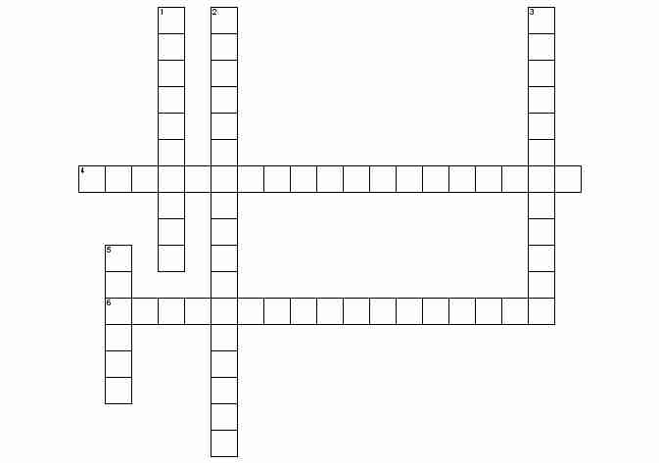

**U1-16**

**Unit 1 Crossword Puzzle**

**Across**

|  |  |
| --- | --- |
| 4. | the variable in an experiment that is changed in order to observe some result |
| 6. | the group in an experiment that receives the independent variable, the abnormal condition |

**Down**

|  |  |
| --- | --- |
| 1. | inference or educated guess as to the cause for an observation |
| 2. | the variable in an experiment that is observed as a result of some independent variable |
| 3. | the group in an experiment that does not receive the independent variable, the normal condition |
| 5. | a well established explanation of a natural phenomenon |

8 Characteristics of Life

**U1-16**

|  |  |  |
| --- | --- | --- |
|  | **Definition** | **Examples** |
| **S\_\_\_\_\_** |  | Protein synthesis, |
| **T\_\_\_\_\_** |  |  |
| **E\_\_\_\_\_** |  |  |
| **R\_\_\_\_\_** |  |  |
| **N\_\_\_\_\_** |  |  |
| **G\_\_\_\_\_** |  |  |
| **R\_\_\_\_\_** |  |  |
| **R\_\_\_\_\_** |  |  |

**U1-12**

**PRACTICE!**

**Place the following examples of STERNGRR processes in the correct box on the previous page. The first one has been done for you.**

* Protein synthesis
* Anaerobic respiration occurs in cells when there is not enough oxygen
* Fungi decompose dead remains
* Hormones used to communicate and regulate body processes
* Internal or external fertilization
* Nervous system controls bodily processes
* Unicellular organisms are asexual
* Sperm meets an egg
* Sexual reproduction
* Removing unused molecules from food
* Plants exchange gasses through their stomata
* Photosynthesis
* Osmosis
* Anaerobic respiration occurs in cells with no mitochondria
* Animals consume other organisms and absorb food
* Diffusion
* Facilitated Diffusion
* Plants make their own food
* Removing fluids to balance water
* Aerobic respiration occurs in the mitochondria
* Active Transport

**Read the following story about Sammy and answer the question that follows.**

Sammy was a normal, healthy boy. There was nothing in his life to indicate that he was anything different from anyone else. When he completed high school, he obtained a job in a factory, operating a machine press. On this job he had an accident and lost his hand. It was replaced with an artificial hand that looked and operated almost like a real one. Soon afterward, Sammy developed a severe intestinal difficulty, and a large portion of his lower intestine had to be removed. It was replaced with an elastic silicon tube.

Everything looked good for Sammy until he was involved in a serious car accident. Both of his legs and his good arm were crushed and had to be amputated. He also lost an ear. Artificial legs enabled Sammy to walk again, and an artificial arm replaced the real arm. Plastic surgery enabled doctors to rebuild the ear. Over the next several years, Sammy was plagued with internal disorders. First, he had to have an operation to remove his aorta and replace it with a synthetic vessel. Next, he developed a kidney malfunction, and the only way he could survive was to use a kidney dialysis machine (no donor was found for a kidney transplant). Later, his digestive system became cancerous and was removed. He received nourishment intravenously. Finally, his heart failed. Luckily for Sammy, a donor heart was available, and he had a heart transplant.

It was now obvious that Sammy had become a medical phenomenon. He had artificial limbs, nourishment was supplied to him through his veins; therefore he had no solid wastes. All waste material was removed by the kidney dialysis machine. The heart that pumped his blood to carry oxygen and food to his cells was not his original heart. But Sammy's transplanted heart began to fail. He was immediately placed on a heart-lung machine. This supplied oxygen and removed carbon dioxide from his blood, and it circulated blood through his body.

The doctors consulted bioengineers about Sammy. Because almost all of his life-sustaining functions were being carried on by machine, it might be possible to compress all of these machines into one mobile unit, which would be controlled by electrical impulses from Sammy's brain. This unit would be equipped with mechanical arms to enable him to perform manipulative tasks. A mechanism to create a flow of air over his vocal cords might enable him to speak. To do all this, they would have to amputate at the neck and attach his head to the machine, which would then supply all nutrients to his brain. Sammy consented, and the operation was successfully performed.

Sammy functioned well for a few years. However, a slow deterioration of his brain cells was observed and was diagnosed as terminal. So the medical team that had developed around Sammy began to program his brain. A miniature computer was developed: it could be housed in a machine that was humanlike in appearance, movement, and mannerisms. As the computer was installed, Sammy's brain cells completely deteriorated. Sammy was once again able to leave the hospital with complete assurance that he would not return with biological illness.

1. Is Sammy “living” at the end of the story? Why or why not? At what point did you decide that Sammy was no longer “alive”?