Name:________________________

**Unit 4: DNA, Replication, Mitosis, Protein Synthesis, and Biotechnology**

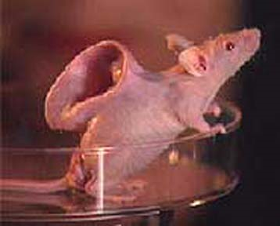

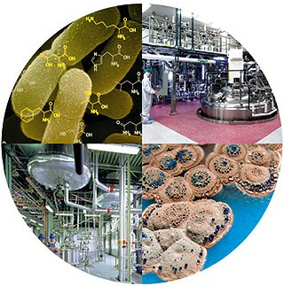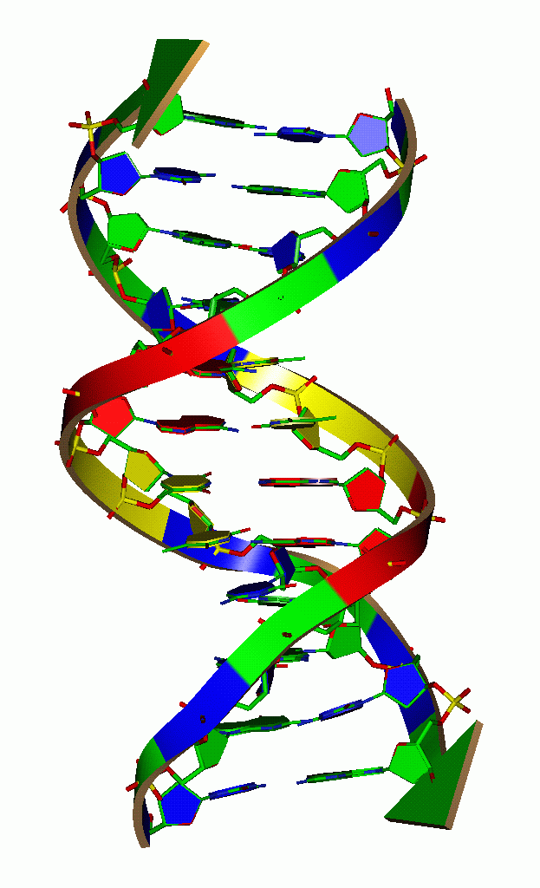

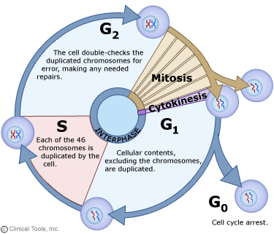

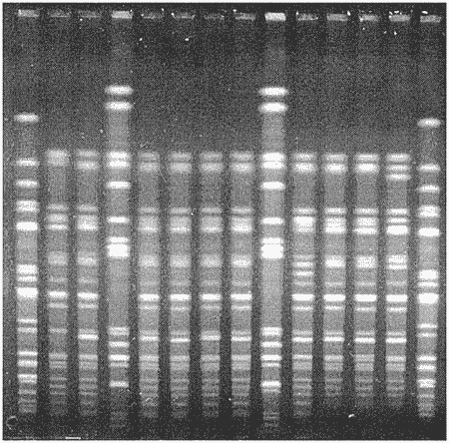

**Key Vocabulary**

DNA

Nucleotide

DNA Replication

Nitrogenous bases

Asexual reproduction

Mitosis

Chromosomes

Gene

Diploid

Somatic

Transcription

Translation

RNA

Polypeptide

mRNA

tRNA

Codon

Anti-codon

Gene therapy

Human genome project

Cloning

Stem cell research

Biotechnology

Transgenic organisms

Gel electrophoresis

**Quiz ___ - DNA Replication**

**Quiz ___ - Mitosis**

**Quiz ___ - Protein Synthesis**

**Quiz ___ - Biotechnology**

**Unit 4 Assessment ___Where in the cell is DNA?!**

**U4-2**

**Label the following in the picture:**

* DNA
* Cell
* Nucleus
* Chromosome
* Gene

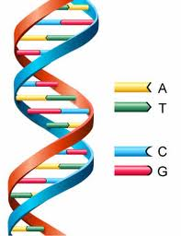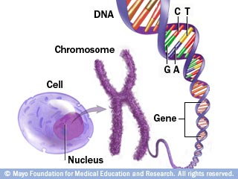

(organelle)

**DNA**

**Answer the following questions while you read the passages on the structure of DNA! (starting on pg. 291)**

1. DNA is made of what units? What are the 3 components of each unit?
2. How many types of nitrogenous bases are there? What are they?
3. What are the 2 components of the DNA “backbone”?

**Pg. 294:**

1. What does a “double helix” look like?
2. What type of bonds hold the two strands of DNA together?
3. Which base pairs will have hydrogen bonds between them?

**Pg. 295:**

1. Where is DNA located in prokaryotes? WHY!?
2. Where is DNA located in eukaryotes?
3. How many chromosomes do humans have in every nuclei of every cell in their body?
4. How long is the DNA in a human cell nucleus? (pg 296)

**DeoxyriboNucleicAcid**

**U4-3**

(_____) is a _____________ ________ (so it is made of _________________!)

* Found in the ___________ of eukaryotes, _____________ of prokaryotes
* You are ______% identical to the person next to you
* In ___________________, DNA gets compacted into _________________



**4 types of bases:**

Adenine: ___

Guanine: ___

Thymine: ___

Cytosine: ___

**Complementary Base Pairing**

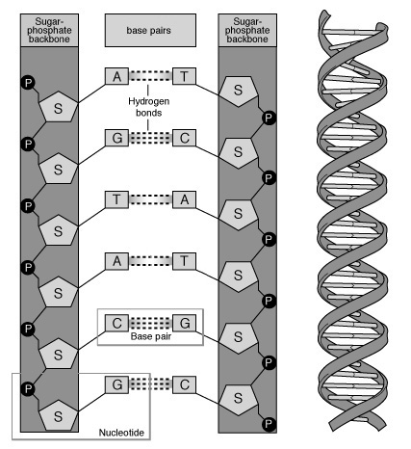The same nitrogenous bases will always pair together

**Adenine (A) pairs with _______________ (___)**

**Cytosine (C) pairs with _______________ (___)**

**Try It!:**

ATTATCGTA

___________________

Two bases are held together by _________________ bonds

**IMPORTANT:** Hydrogen bonds are very _______________!

**You try it!**

**U4-4**

1. The strands below are missing their complementary strands! Write the complementary DNA strand below each DNA strand given.

**Example:** DNA strand: ATGGC

Complementary DNA strand: TACCG

1. A G T T T A C G G C A T
2. A G C C C G A T T A G C
3. How do we know that A always pairs with T and G pairs with C?

A scientist named Erwin Chargaff performed experiments which showed that the ratio of A to T is always 1:1, and the ratio of G:C is always 1:1. Look at the data below and answer questions about it so that you can prove this to yourself!

|  |  |  |  |  |
| --- | --- | --- | --- | --- |
| **Source of Sample** | **Amount of A** | **Amount of G** | **Amount of C** | **Amount of T** |
| **Human liver cell** | 30 | 19 | 19 | 30 |
| **Human lung cell** | 31 | 20 | 20 | 31 |
| **Fish cell** | 28 | 22 | 22 | 28 |
| **Bacteria cell** | 32 | 18 | 18 | 32 |

**Questions about the chart:**

1. Compare the amounts of A, G, C & T in human liver cells. Which nucleotides have the same amount?

2. Compare the amounts of A, G, C & T in human lung cells. Which nucleotides have the same amount?

3. Compare the amounts of A, G, C & T in fish cells. Which nucleotides have the same amount?

4. Compare the amounts of A, G, C & T in bacteria cells. Which nucleotides have the same amount?

5. Look at your answers to #’s 1-4. What pattern are you starting to see?

6. In human lung cells A=31 and T=31. Is the ratio of A:T 1:1, 1:2, 1:3 or 1:4?

7. Which of the four types of cells have about the same amounts of A, G, C and T, and why do you think they have similar DNA?

8. The ratio of A:T is always 1:1 and the ratio of G:C is always 1:1. This means that the amount of A always equals T and the amount of G always equals C. Why does this prove that A pairs with T and G pairs with C?

1. What are A, T, G and C?

Adenine (A), Guanine (G), Thymine (T), and Cytosine (C) are ring shaped nitrogen bases. Adenine and Guanine are purines. Thymine and Cytosine are pyrimidines.

**Questions:**

1. What are A, T, G and C?

a. hydrogen bonds b. nitrogen bases c. nitrogen bonds d. hydrogen bases

2. What is the shape of a nitrogen base?

a. straight line b. ring-shape c. spiral-shape d. gladiator-shape

3. How are two nitrogen bases in DNA connected?

**U4-5**

a. phosphate bond b. carbon bond c. nitrogen bond d. hydrogen bond

1. How do we use nitrogen bases (A, T, G and C) to store genetic information?

We store genetic information in our DNA. Our DNA is made up of 4 different nucleotides. The nucleotides are different because they contain different nitrogen bases (A, T, G and C). We store genetic information as **patterns of nucleotides in our DNA.**The more alike two organisms are, the more alike their DNA is. For example, the DNA of a tiger and a cat is more alike than the DNA of a cat and a flower.

**Questions**:

1. How do we store genetic information in our DNA?

2. True or False. The more alike two organisms are, the more alike their DNA is.

3. The more alike two organisms are, the more alike their DNA is. Based on this statement, look at the DNA of the animals below, and put them on a timeline *based on how alike their DNA is*.

**Example**: Tiger(ACT)___________Mouse(ACC)_______________Flower (CCC)

**Put these Animals on the timeline:**

Frog: ATGGTTT Jellyfish: ATTAGGT Butterfly: ATTAGTT

Fish: ATTGTTT Elephant: GGGGTTT Starfish: ATTATTT

Bird: AGGGTTT Bacteria: ATTAGGC

Bacteria_______________________________________________________________________________________Elephant

ATTAGGC GGGGTTT

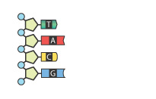1. Which nitrogen bases are needed to complete the DNA strand pictured below? Give your answer in order from top to bottom.

* + 1. T,A,G,C
    2. A, T, G,C
    3. A,T,C,G
    4. C,G,T,A

1. When one DNA molecule is replicated, the result is two DNA molecules. What is true of the second DNA molecule?
   * 1. It is identical to the first DNA molecule
     2. The sequence of bases, from top to bottom, is opposite the first DNA molecule sequence
     3. It is half the size of the first DNA molecule
     4. It is twice the size of the first DNA molecule

3. What is the role of enzymes in the DNA replication process?

* + 1. Enzymes read the DNA code and build a new DNA molecule from scratch
    2. Enzymes link together to form a template for a new DNA molecule to be built
    3. Enzymes split the DNA molecule in half, then transport matching nitrogen bases to each rail
    4. Enzymes link adjacent nucleotides together, becoming an integral structure of the DNA

**DNA Replication**

**U4-6**

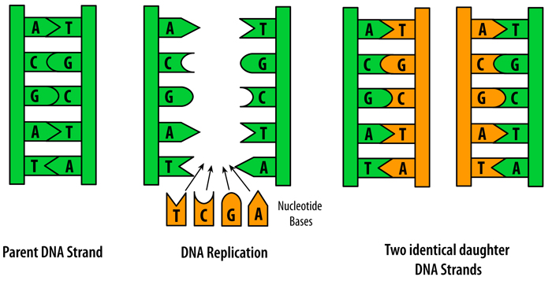

What does “**replication**” mean?!

|  |  |
| --- | --- |
| **WHAT** is it? |  |
| **WHERE** does it happen? |  |
| **WHY** does DNA need to make a copy of itself? | Cells divide for an organism to _______ or ______________. Every ______ cell needs a _______ of the DNA to know how to be a cell. DNA makes an exact _______ of itself _________ the cell ___________. |
| **HOW** does it occur? | 1. **UNZIP**: An enzyme “__________” the 2 strands of DNA by breaking the weak ______________bonds 2. **ADD**: New nucleotides are added to the old strands   (REVIEW: A= ____; C= ____)   1. **ZIPUP**: Another _______________ zips the strands back up 2. **PROOFREAD**: DNA polymerase “______________” the strands to make sure there are no mistakes |

**🡪**DNA replication is ___________________________ = when the DNA copies itself, it always has ____ parental strand, ___ daughter strand

**Semi: _______________________**

**Conservative: _______________**

|  |  |
| --- | --- |
| **Original Strand** | **Step 1: ______________** |
| **Step 2: ______________** | **Step 3&4: ______________**  **_______________** |

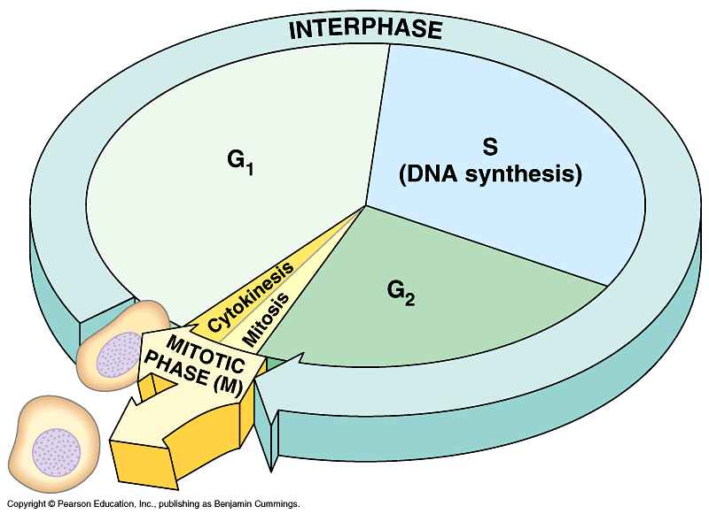

**U4-7**

**Cell Cycle**

* Two main stages:
  1. ______________________
  2. ______________________
* It takes ___ to ___ hours
* ____% of a cell’s time is spent in INTERPHASE

|  |  |
| --- | --- |
| **Stage** | **What happens?!** |
| **Growth 1 (G1)** |  |
| **Synthesis (S)** |  |
| **Growth 2 (G2)** |  |
| **Mitosis (M)** |  |
| **Cytokinesis** |  |

**Mitosis**

(1 cell 🡪 2 cells)

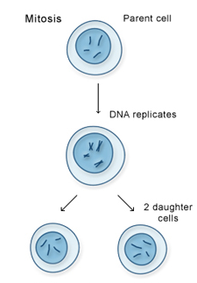

|  |  |
| --- | --- |
|  | **MITOSIS** |
| **Type of Reproduction** | asexual |
| **Used for?** |  |
| **Starts with?** | 1 diploid cell (____) |
| **Makes?** | 2 __________ diploid cells |
| **# of Divisions?** |  |
| **Variation**  **(genetic differences)?** | NO |

**A Closer Look at Mitosis!**

**U4-8**

*Use the micro-viewer and the insert to help you complete these notes.*

*The slides show mitosis in an* ***animal cell****.*

**Forward**

Slide 1

a. How does an animal begin to develop from single cell?

b. What is the equatorial plate?

**Slide 1 – The Zygote**

1. Define Zygote:
2. Draw the slide and label structures.
3. Where did the two masses of chromatin come from?

Slide 2

**Slide 2 – Prophase**

1. Draw the slide and label the structures
2. What is happening to the chromosomes?
3. Where are the chromosome pairs moving to?

**Slide 3 – Metaphase**

1. What is the star-like structure?
2. Where do the star-like structures come from?

Slide 3

3. What structures hold the chromosomes together in the middle?

**Slide 4 – Metaphase-Polar view**

1. How many chromosomes are seen on the equatorial plate?
2. Look back at slide 3, where are the centromeres located?

**Slide 5 – Early Anaphase**

1. Draw the slide

Slide 5

1. How many groups are the duplicated chromosomes forming?
2. Chromosomes are pulled by what structure?
3. Where do the spindle fibers attach?

**Slide 6 – Anaphase**

1. What type of microscope is used to see the chromosomes?

2. What are microtubules?

Slide 6

3. When do Chromosomes look beaded?

**Slide 7 – Telophase**

1. Draw this slide
2. What is happening to the chromosomes?

3. What is happening to the cell membrane?

**Slide 8 – Late Telophase**

Slide 7

1. Is the separation complete? yes no
2. What will soon happen to the chromosomes?
3. Is the process of mitosis the same in humans? yes no
4. How many chromosomes did scientists think humans had up until 1958?

5. What enabled scientists to determine humans only have 46 chromosomes?

|  |  |  |  |  |  |  |
| --- | --- | --- | --- | --- | --- | --- |
|  | **1st** | **2nd** | **3rd** | **4th** | **5th** | **6th** |
| **Drawing** |  |  |  |  |  |  |
| **What is happening?** |  |  |  |  |  |  |

**Mitosis**

**U4-9**

**Using the book, draw each of the six steps of mitosis and describe what is happening in each step:**

**Chromosomes**

|  |
| --- |
| What would 1 daughter cell look like after mitosis? |
| **After MITOSIS:** |

**Sketch the following: This is a cell with a 2 chromosomes:**

|  |  |
| --- | --- |
| 1 chromosome | 1 pair of homologous chromosomes |
|  |  |
| 1 chromosome after DNA replication | 1 pair of homologous chromosomes after DNA replication |
|  |  |

**EOC Practice**

1. A zebra has 48 chromosomes in it somatic cells.

What most likely will be the chromosomal number in each daughter cell after mitosis?

* 1. 48
  2. 96
  3. 12
  4. 24

1. If a tongue cell in an alligator has 20 chromosomes, how many chromosomes will be found in its liver cells?
2. 40
3. 60
4. 15
5. 10
6. The following images demonstrate cell division in which 2 identical daughter cells are produced. Which of the following best describes this process?

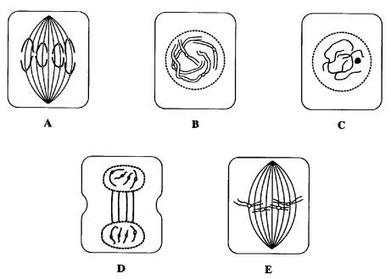

* 1. Sexual reproduction and mitosis
  2. Sexual reproduction and meiosis
  3. Asexual reproduction and mitosis
  4. Asexual reproduction and meiosis

1. Which of the following processes must occur before the process pictured in A (use the image from question 3)?
2. E
3. C
4. D
5. B
6. Which term best describes the type of celldivision in which parent cells produce daughter cells with the same number of chromosomes as the parent cells?
7. Mitosis C. Spermatogeneis
8. Meiosis D. Oogenesis

6. Uncontrolled cell division is characteristic of

A. Cleavage C. Regeneration

B. Cancer D. Crossing over

1. Warts result when certain viruses cause skin cells to reproduce at a high rate. This rapid reproduction of skin cells is due to the viruses causing
2. Cellular digestion

**U4-10**

1. Mitotic cell division
2. Synthesis processes
3. Meiotic cell division
4. Mitosis and meiosis are similar because both processes
5. Produce diploid gametes from haploid cells
6. Involve the formation of chromosomes
7. Make 4 cells
8. Involve the replication of DNA before division
9. Which process is represented by the series of diagrams below?



A. Gametogenesis C. Meiotic cell division

B. Fertilization D. Mitotic cell division

10. Presence of a cancerous mass in a lung is the result of

1. Prolonged exposure to very dry air
2. The introduction of chemicals through the skin
3. Uncontrolled mitotic division and growth of cells
4. Meiotic cell division

10. Which sequence represents the correct order of processes that result in the formation and development of an embryo?

A. fertilization 🡪 meiosis 🡪 mitosis

B. fertilization 🡪 mitosis 🡪 meiosis

C. meiosis 🡪 fertilization 🡪 mitosis

D. mitosis 🡪 fertilization 🡪 meiosis

1. Why does a cell undergo mitosis?
2. What must happen before mitosis can occur?
   1. DNA Transcription
   2. DNA replication
   3. DNA base pairing
   4. DNA Translation
3. What kind of reproduction is mitosis?
4. What kind of cells undergo mitosis?

**U4-11**

1. Describe homologous pairs of chromosomes?
2. What happens in the G phase of interphase?

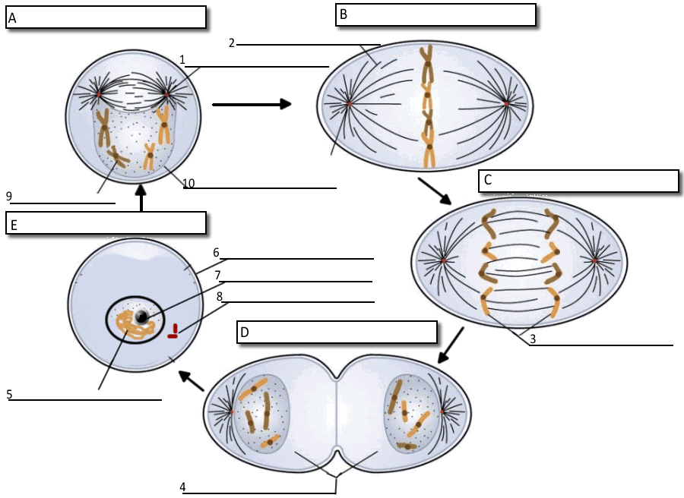

1. What moves the chromatids during mitosis?

2. What anchors the spindle?

3. How many daughter cells are created from mitosis and cytokinesis?

4. During what phase does cytokinesis begin?

5. If a human cell has 46 chromosomes, how many chromosomes will be in each daughter cell?

6. If a dog cell has 72 chromosomes, how many daughter cells will be created during a single cell cycle?

7. Each of these daughter cells will have how many chromosomes?

8. The nuclear membrane dissolves during what phase?

9. In the cell pictured above, how many

chromosomes are present during prophase?

10. What structure holds the individual chromatids together?